Thank you for booking with [INSERT NAME HERE]. This is your booking confirmation. The information below covers everything you need to know prior to the start of your course - please read it carefully.

We hope you will enjoy the training with [INSERT NAME HERE] and please do not hesitate to contact us if you have any concerns.
[INSERT NAME HERE]
COURSE TITLE:
[INSERT DATE HERE]
COURSE DATE:
[INSERT TIME HERE]
[INSERT TIME HERE]
START TIME: FINISH TIME:
[INSERT NAME/S HERE]
STUDENT

Course Requirements

- Students engage in High Risk Work are required to be 18 years of age or over.
- Students are required to have adequate English language numeracy and literacy skills.
- Students are required to provide proof of the relevant pre-requisite.

Note: When enrolled into two courses consecutively, and the first course is pre-requisite for the second course (for example Dogging and Basic Rigging), you MUST lodge your licence application for the first course before you can undertake the second course. This requires 100 points identification (see list).

Student Checklist
It is important that you wear the correct clothing and bring the required documents with you to the course.

- Photo Identification i.e. Driver’s Licence or Passport

(100 points of identification required to lodge your application)
- Other High Risk Work licences (if applicable)

- Work safety shoes

- High visibility shirt

- Scaffold belt and tools (scaffold courses only)

Facilities

[INSERT FACILITIES HERE] The training facilities include fridges and microwaves for anyone to use, as well as tea and coffee making facilities. A shower is also available on site for our students.

Re-assessment Procedure

Students who do not pass either a theory or practical component of an assessment may be eligible to undertake a re-assessment of the failed component. The conditions below may apply:

- Re-assessment dates for High Risk Work require a minimum of three business days for re-scheduling and regulator notification
- Re-assessment dates are subject to availability, and may incur an additional cost.
- Availability times may vary, subject to assessor, plant and equipment or site requirements and may take up to 90 days.
- Re-assessments for High Risk Work may not be undertaken if the completion extends the total allowable time for the training beyond the regulators requirements (6 months).
- All other re-assessments are at the discretion of the trainer/assessor.

Our Location
[INSERT ADDRESS HERE] | [INSERT MAP IS SHOWN]  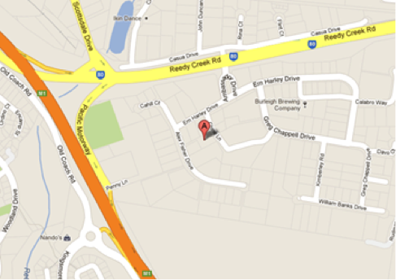
[INSERT DIRECTIONS HERE]

Cancellation Policy & Terms and Conditions

[INSERT POLICY HERE]

